CSS 475 A Database Systems

Homework 1 (20 possible points) [4% of final grade]

Due BY: April 8 (Sunday) 11:59:59 PM

1. (3 points) dentify at least 2 informal queries and 2 update operations that you would expect to apply to the database shown in Figure 1. (e.g. an example query can be: List the name of the student whose Student_number is 17; an example update can be: Insert a new course in the database whose Course_name = Algorithm, Course_number = CS4300, Credit_hours = 4, Department = CS. These 2 examples CANNOT be used as your answers)

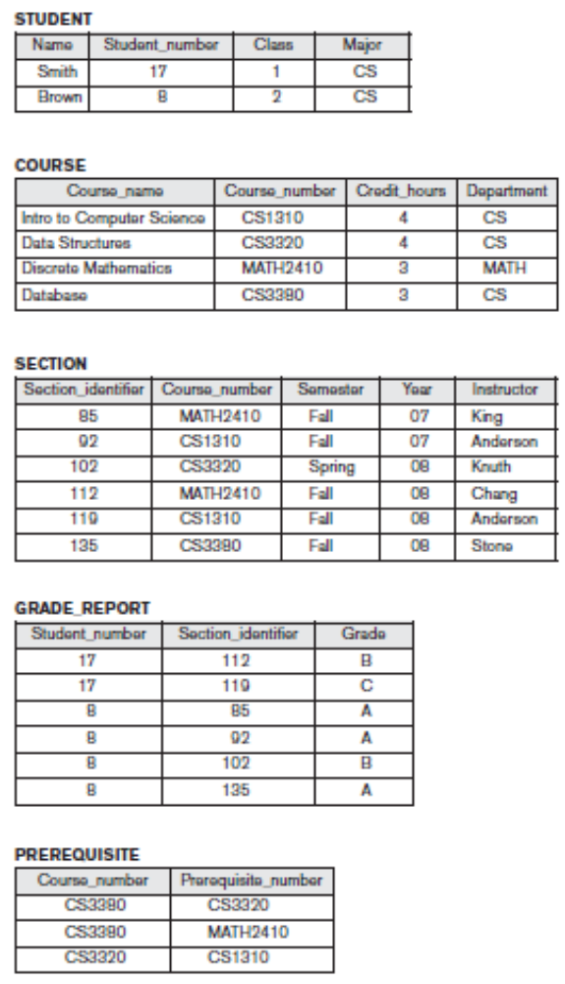
Figure 1. Example database (from the textbook: Fundamentals of Database Systems, by R. Elmasri & S. B. Navathe, Pearson.)
- List course name of the course that Course_number is CS1310.
- List the section identifier of the section which Course_number is MATH2410.
- List the student number of the grade report that Section_identifier is 112.
- List the course number of the prerequisite which Prerequisite_number is CSS320.

- Insert a new student in the database whose Name = Jolly, Student_number = 7, Class = 3, Major = CS.
- Insert a new section in the database which Section_identifier = 113, Course_number = CS4310, Semester = winter, Year = 08, Instructor = Tom.
- Insert a new grade report in the database that Student_number = 7, Section_identifier = 113, Grade = A.
- Insert a new prerequisite in the database which Course_number = CS4310, Prerequisite_number = CS3380.

2. (3 points) Name all the relationships among the records of the database shown in Figure 1 (e.g., each SECTION record is related to a COURSE record. This example can be included in your answer).
- Each SECTION record is related to a COURSE record.
- Each STUDENT record is related to a GRADE_REPORT record.
- Each COURSE record is related to a PREREQUISITE record.
- Each SECTION record is related to a GRADE_REPORT record.
- Each SECTION record is related to a PREREQUISITE record (redundancy).

3. (3 points) Cite at least 5 examples of integrity constraints that you think should hold on the database shown in Figure 1. The 5 examples of integrity constraints you pick should at least belong to 2 (and preferably 3) categories as discussed in class.
- Each student must have a unique Student_number (key constraint).
- Each course must have a unique Course_number (key constraint).
- Each section must have a unique Section_identifier (key constraint).
- Every Student_number in student must be same as Student_number in grade report (referential integrity).
- Every Course_name in course must be same as Course_number in section (referential integrity).
- Every Section_identifier in section must be same as Section_identifier in grade report (referential integrity).

4. (11 points) Choose a database application (cannot be the same as the University or Company examples in the textbook) with which you are familiar and contains at least 3 entity types (tables). Design & draw the schema and show a sample database for that application, using the notation similar to Figures 1. List (or draw) all relationships and constraints you think are necessary for this schema. Think of at least 2 types of different users for your database, and design a view for each. Need to describe or draw the view and list what type of users the view is designed for.

CLIENT
Client_name | Username | Point
Jolly | bee123 | 218
Tom | cru456 | 47

BOOK
Book_name | Author | Publisher_name | Book_number (ISBN) | Price
Database | Olivia | AK Press | 978-3-16-148410-0 | $195.00
Software Engineering | James | Pearson | 978-0-13-394303-0 | $149.99
Database System Management | Jack | Wiley | 978-1-84-935203-5 | $98.00
SQL | John | Pearson | 978-1-18-827365-9 | $49.99

PUBLISHER
Publisher_name | Address | Number
Pearson | London, United Kingdom | (800) 677 - 6337
AK Press | Oakland, CA | (510) 208 - 1700
Wiley | Hoboken, NJ | (800) 758 - 9477

Each BOOK record is related to a PUBLISHER record.
Each client must have a unique Username.
Each book must have a unique Book_number.
Each publisher must have a unique Publisher_name.
Every Publisher_name must be same as Publisher_name in publisher.

Book Seller View
Client_name | Username | Book_name | Author | Price
- Book sellers care who their clients are, what kinds of books they sell, how much books are.
Client View
Point | Book_name | Author | Price
- Clients care how many points they have, what kinds of books they want to buy, and how much books are.

